Instructions for cloning a repository from github using Egit on Eclipse, version Kepler

1. Open Eclipse and go to File → Import...

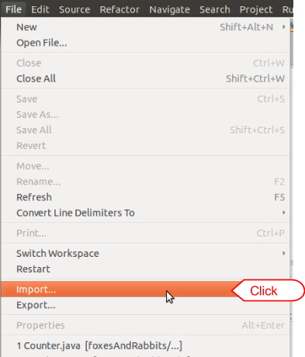

1. Click the “Git” folder and choose “Projects from Git”

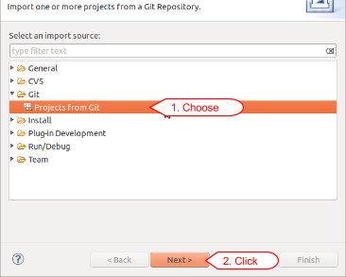

1. On the next window click “Clone URI”, then click “Next>”

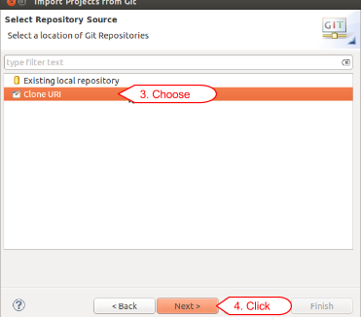

1. From the Github web page of the repository, copy the “HTTPS clone url” given at the bottom right of the page

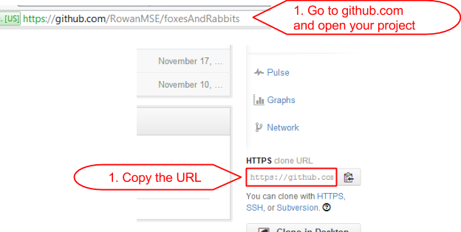

1. Copy this into the “URI” field in eclipse and the “Host” and “Repository Path” are automatically filled out, Click “Next>”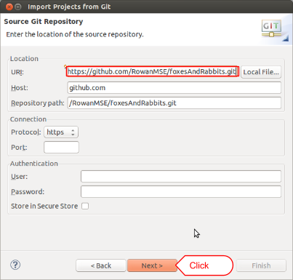
2. Choose the branches to import and click “Next>”

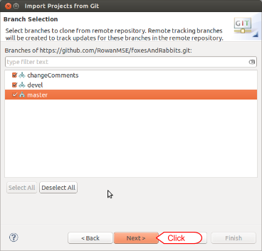

1. Assign it a directory with a git folder, for example “C:\\Users\username\git\projectName” , only modifying the destination drive, username, or projectName. NOTE: IT MUST BE PUT IN A GIT FOLDER.

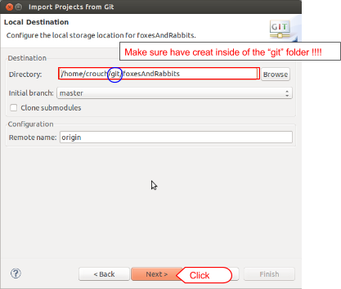

1. Select “Import as general project”, and click “Next>”

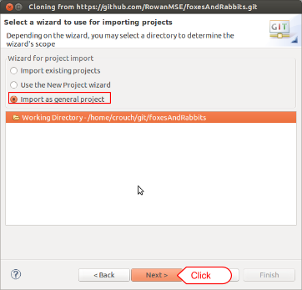

1. You can give it a project name or keep it the same and click “Finish”

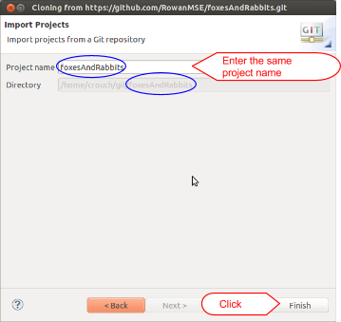

1. The project should be loaded now but is not recognized as a Java Project. Right click on the project folder and choose “Delete” Make sure “Delete project contents on disk” IS NOT CHECKED!! Also copy the project path location

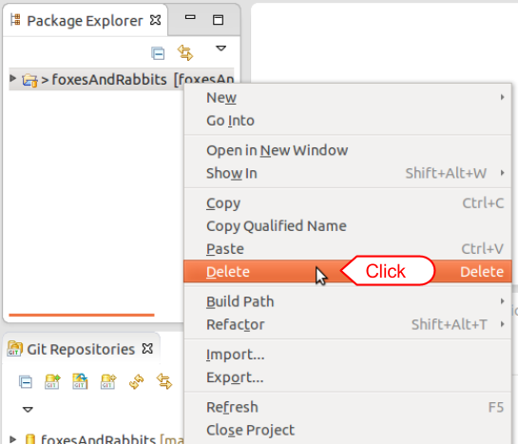

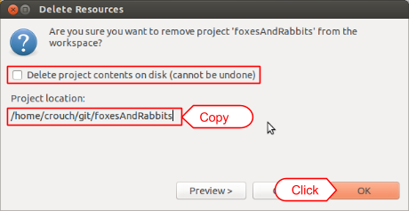

1. Go to File → new → Java Project

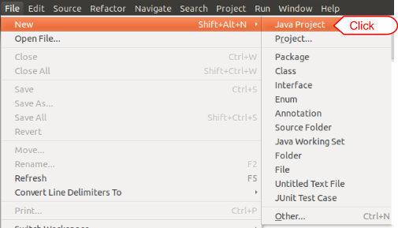

1. Uncheck “Use default location” and paste the path of the project there. Use the same name of the project for the Project Name field and click Finish. The project is ready to use.

